Elmwood Wrestling Tournament

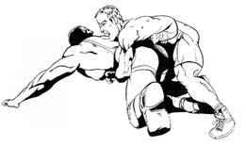

Saturday December 17, 2016
@ Elmwood High School

Junior High High School

Grades: Grades 7-9 Grades 9-12
Time: 9 am start Approx. Noon
Weigh-ins: Email weights, In person Dec 17 deadline Dec 14, @ 10 AM
@ 5 PM

Cost: $20 per athlete, $30 for Gr 9 Athlete Wrestling in both tournaments

Contact Steve @ elmwoodwrestling@hotmail.ca
A reply will be sent to confirm receipt of weights.

Registration: In order to make the registration process as smooth as possible, we request that a team representative (coach or manager) make one single payment for all athletes competing. Cheques can be made out to Elmwood High School, or we will accept cash.

Registration starts at 8 AM for Junior High Athletes, and all athletes must check in no later than 8:30 AM. Also, there will be "spot checks" with a 1Kg allowance.

In-person Registration starts at 10 AM for Senior High, and all athletes must check in and weigh-in no later than 10:30 AM. MAWA would appreciate it if the Senior High teams could pre-register their athletes for this tournament. Please complete the pre-registration form and email it in to us by Friday December 16 at noon.

For Grade 9 athletes wishing to compete in both Junior and Senior High events, the registration fee is $30, and the athlete must weigh-in during senior high weigh-ins as well.

Canteen will be run by Pita Pit.

