Grant Park Open
Wrestling Tournament

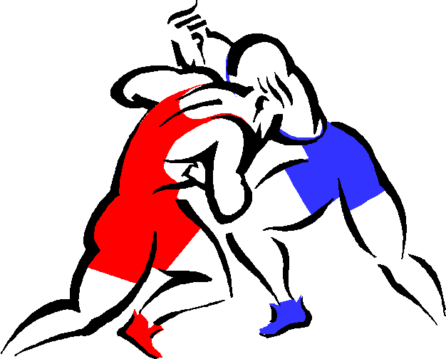

Date – Friday, March 3rd - Elementary and Junior High.
Wrestling will start at 5:00 p.m. and continue until completion. Please report all scratches (in person or email) as soon as possible. There will be no dinner break.

Date – Saturday, March 4th – Senior High
Wrestling will start at approximately 10:00 a.m. and continue until completion. There will be no lunch break.

Location -
Grant Park High School – 450 Nathaniel Street, Winnipeg, MB.

Entry Fee
$20.00 per athlete – cheques can be made out to Grant Park High School. There is no extra charge for grade nine athletes that are wrestling in both the junior and senior high tournament.

Eligibility
All wrestlers must be registered with MAWA in order to be eligible for the tournament.
Elementary – Grade 6 and under
Junior High – Grade 7 - 9
Senior High – Grade 9 -12 but also must cannot be over 18 years of age on the date of the tournament.

Weigh ins
At home weigh-ins to be done by Coaches and emailed in by no later than 6 p.m. on Wednesday, March 1st. Make sure to use the registration form provided.
For all wrestlers send in actual weights in kg, not the anticipated weight class.

To check weights, we may complete Red Dot weigh-ins at the tournament. Two athletes from each team may be randomly selected and weighed. They must be within 1 kg of their weight class. If they weigh over, they will be removed from the tournament. In the event both wrestlers are overweight, the entire team will be weighed. This will ensure that all weights are accurate and ensure safety of the wrestlers.
Email: mkattenfeld@gmail.com

Rules
CAWA/FILA rules.
* For elementary wrestling, only one hip toss is allowed per round. After the points are awarded, both wrestlers are brought to standing following the rules for a miss throw.

Skin Check
Please ensure that a thorough skin check in done on the athletes prior to the competition. If the athlete is questionable, don’t enter them in the competition. An athlete may be pulled out of the tournament if a skin problem is detected.

Draw
Elementary and junior high wrestlers will be grouped into pools of 2 or 6 wrestlers. All weight classes will be run as Round Robins to get the wrestlers as many matches as possible.

For senior high wrestlers we will be following CAWA weight classes for this tournament.
Modified bracket – double elimination or round robin; depending on the size of each weight class.

WEIGHT CLASSES

MALE: 42, 46, 50, 54, 58, 63, 69, 76, 85, 100, 115, 130 kg.
FEMALE: 38, 40, 43, 46, 49, 52, 56, 60, 65, 70, 80, 90 kg.
Awards
Top 3 wrestlers in each weight class or pool.

If you have any questions, please contact Mike Kattenfeld for more information.
(204) 452-3112 (School)
(204) 510-7981 (Cell)
mkattenfeld@gmail.com

