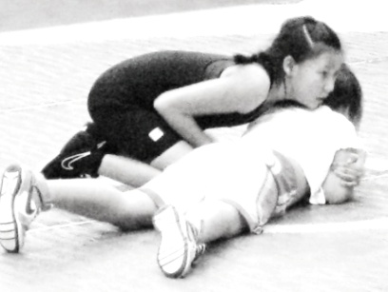 LAVALLEE 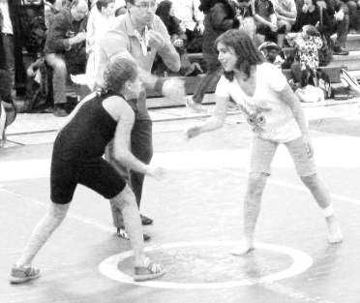
COMMUNITY
WRESTLING CLUB
Learn to Wrestle
Boys Girls

Mondays 5:45 -6:45 pm and
Thursdays 5:45 – 6;45 pm
October to December – Session 1
January to March Session 2
At Lavallee School Gym
505 St. Anne’s Rd.

Session 1 Registration Monday, Oct. 5 at 5:45 pm Cost $75.00
Session 2 Registration Monday Jan. 4 at 5:45 pm Cost $75.00
Parent/Guardian must attend first class to sign registration forms.
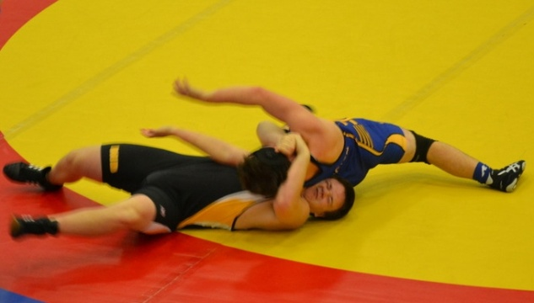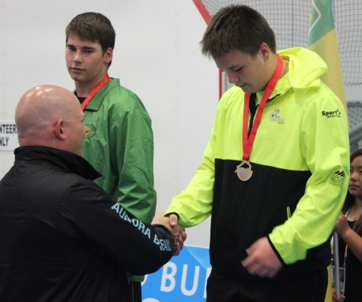
Lavallee wrestler Michael Hickey wins gold for Team Manitoba at the 2015 Western Canada Summer Games in Fort McMurray, AB

Freestyle wrestling (Olympic style) is taught in a safe fun environment.

Coaches: Mokhtar Hakimi, Shoja Hakimi, Duane Buhler, Kara Diakow. All coaches NCCP trained.

All participants must be members of the Manitoba Amateur Wrestling Association. MAWA Non-competitive Membership fee is included in club fees. Additional MAWA fee for Competitive athletes. Make cheques payable to Lavallee Community Wrestling Club.

Contact: lavalleewrestling@hotmail.com for more details.

