**Morden/Winkler**

**Wrestling Tournament**



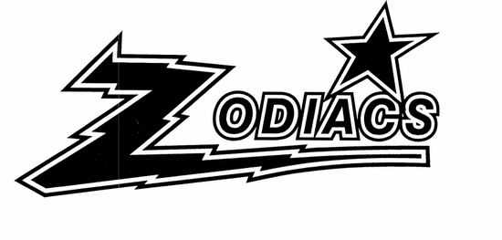

**Date – Saturday, February 10th – Senior High (using 1 mat)**

Wrestlers should arrive before 8:45 am (all registrations will be closed at 9 am). Wrestling will start at 9:30 a.m. and continue until completion. Please report all scratches (in person or email) as soon as possible.

**Date – Saturday, February 10th – Elem and Junior High (using 2 mats)**

Wrestlers should arrive before 8:45 am (all registrations will be closed at 9 am). Wrestling will start at approximately 9:30 a.m. and continue until completion. There will be no lunch break.

**Location -**

Morden Collegiate Institute, 345 5th Street, Morden, MB.

**Entry Fee**

$20.00 per athlete – cheques payable to École Morden Middle School. There is no extra charge for grade nine athletes that are wrestling in both the junior and senior high tournament. **Please note that junior High and high school will run simultaneously in the same gym on a different mat.**

**Eligibility**

All wrestlers must be registered with MAWA in order to be eligible for the tournament.

**Elementary** – Grade 6 and under

**Junior High** – Grade 7 - 9

**Senior High** – Grade 9 -12 but also cannot be 19 years of age on the date of the tournament.

**Weigh ins**

At home weigh-ins to be done by coaches and emailed in by no later than **6 p.m. on Wednesday, February 7th**. Make sure to use the registration form provided.

For all wrestlers send in actual weights in kg, not the anticipated weight class.

To check weights, we may complete Red Dot weigh-ins at the tournament. Two athletes from each team may be randomly selected and weighed. They must be within 1 kg of their weight class. If they weigh over, they will be removed from the tournament. In the event both wrestlers are overweight, the entire team will be weighed. This will ensure that all weights are accurate and ensure safety of the wrestlers.

**Elem & Junior High Registrations – Email Dan:** [**dmuggridge@westernsd.mb.ca**](mailto:dmuggridge@westernsd.mb.ca)

**High School Registrations – Email Jake:** [jacob.sailer@gvsd.ca](mailto:jacob.sailer@gvsd.ca)

**Rules & Officiating**

Wrestling Canada Rules Apply - CAWA/FILA rules.

Certified MAWA/CAWO officials will officiate.

* For elementary and junior high wrestling, only one hip toss is allowed per round. After the points are awarded, both wrestlers are brought to standing following the rules for a miss throw.

**Skin Check**

Please ensure that a thorough skin check in done on the athletes prior to the competition. If the athlete is questionable, don’t enter them in the competition. An athlete may be pulled out of the tournament if a skin problem is detected.

**Draw**

All wrestlers will be grouped into pools of 2 to 6 wrestlers. All weight classes will be run as Round Robins to get the wrestlers as many matches as possible. Draws will be sent out ahead of time as a courtesy to coaches, but also to help with an efficient start time. We plan on announcing matches & names to help start on time when first brackets are ready.

**Awards**

Top 3 wrestlers in each weight class or pool.

**Medical / Emergency Treatment (On site)**

Morden Physiotherapy

Tim Schantz (Owner) BESS(AT), CAT(C), CPT.

Certified Athletic Therapist

If you have any questions, please contact Dan Muggridge for more information.

(204) 822 6225 (School)

(204) 823 2400 (Cell)

[dmuggridge@westernsd.mb.ca](mailto:dmuggridge@westernsd.mb.ca)