 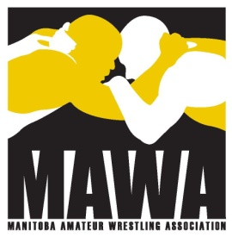

*NCCP Coaching Clinic*

C:\Users\User\AppData\Local\Microsoft\Windows\Temporary Internet Files\Content.IE5\ZD76RGZI\MC900332840[1].wmf

Wrestling Competition Introduction

Part A

**May 23, 24, & 25, 2014**

**Friday, May 23 5:00-9:00 and Saturday, May 24 9:00 – 4:00**

**Sport Manitoba**

**Sport for Life Building**

**145 Pacific Ave.**

**and**

**Sunday, May 25 (on mat training) 10:00 – 3:00**

Freight House (Central Community Club)

200 Isabel St.

Winnipeg, MB

Cost $90.00 (includes coach’s manual and DVD)

The Competition Introduction course is required for those who want to coach competitive wrestling for junior and senior high school age athletes. Please note that this is a two part course. Part B must also be completed to be considered a trained coach at this level.

Contact the Manitoba Amateur Wrestling Association at [mawawrestling@mts.net](mailto:mawawrestling@mts.net) for more information. To register go to [www.mawawrestling.ca](http://www.mawawrestling.ca) and download the registration form included under the heading NCCP Coaching Clinics. Email completed form to [mawawrestling@mts.net](mailto:mawawrestling@mts.net). Registration deadline is Wednesday May 14.

Make cheques payable to MAWA. Mail to 360 Wales Ave. Wpg. MB R2M 2S9. Or pay online by PayPal using the online payment centre on the MAWA website at [www.mawawrestling.ca](http://www.mawawrestling.ca) under the tab labelled “more”. Payment is due with registration.