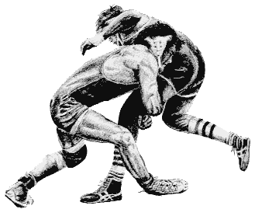
St. Paul’s High School
Invitational
Wrestling Tournament

Saturday, March 7, 2015

AGE GROUPS
Elementary, Junior High, & High School

TOURNAMENT LOCATION
St. Paul’s High School (Multiplex Building)
School Address: 2200 Grant Avenue, Winnipeg, MB
Access Multiplex via Holland Blvd. (the street just east of the school)

START TIMES
Elementary & Junior High Tournament
Registration: 9:00 am
All wrestlers who were entered must check in via their head coach
This is to ensure no scratches during any of the Elementary and/or Junior High draws.
Wrestling starts: 9:30 am

High School Tournament
Weigh-ins: 11:30 pm
Wrestling starts: 1:00 pm

ENTRY FEE
$20.00 per athlete - Cheques payable to, St. Paul’ s High School
See Mike Watson personally with your team’s entry fees. We won’t accept payment from individual athletes or parents.

ELIGIBILITY
- Elementary: Grade 6 and under
- Junior High: Grades 7 – 9
- Senior High School: Grades 9 – 12 (Must be born during or after 1996 and cannot be over 18 years of age on the date of the tournament).

All wrestlers must be registered with MAWA

WEIGH INS / REGISTRATION
At home weigh-ins for Elementary & Junior High: To be completed by Coaches and e-mailed in by no later than 5:00 pm on Wednesday, March 4th. Email: Mike Watson at mwatson@stpauls.mb.ca

High School Wrestlers: On site weigh-ins for high school wrestlers at 11:30.

WEIGHT CLASSES
Weight Classes in Elementary & Junior High will grouped to ensure as many matches as possible for those participating.

DRAW
Modified bracket – double elimination or round robin; depending on the size of each weight class.
If there are not enough wrestlers to create a bracket, we may group athletes in weight classes to ensure a maximum number of matches.

RULES CAWA/FILA rules

SKIN CHECK
Please ensure each athlete undergoes a thorough skin check prior to the competition. If the athlete’s skin condition is questionable, do not enter them in the competition. An athlete may be pulled out of the tournament if a skin problem is detected.

AWARDS
Medals will be awarded to top finishers in each weight division.

There will be a canteen on site

For further information contact: Mike Watson
mwatson@stpauls.mb.ca
Cell: (204) 227-0656
School: (204) 831-2321


